Back where I started

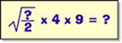

I started with a three digit number.
I divided it by two.
I then took the square root of the result.
I multiplied this by 4 and then by 9.
I found that I had got back to the number
I had started with.
What number did I start with?

648

